Design document: FoodBridge
By: Simeon Markov
Institution Name: Fontys UAS
Course/Class: ICT/EN08
Date: 2025-12-11

Introduction
The purpose of this document is to set a clear design plan, illustrating incorporated layout principles. It includes the wireframing process, explaining each wireframe and the user flow as well as the design of the database (shown in EER diagram) explaining fields and relations between tables.

Design Guide (UI/UX Principles)
This section presents the initial design plan (incorporating layout principles, accessibility, etc.) User-Centric: Interfaces should align with the organizational needs and expectations (key features).
Visual Hierarchy: Having a strategic application of layout, color, typography, and spacing to emphasize high-priority data while minimizing cognitive load.
Simplicity and clarity: Presenting complex information in digestible formats without overwhelming users with excessive visual elements (for example adhering to the 5-second rule).
Consistency: Consistency across typography, color schemes, button styles, and interactive behaviors.
Appropriate Visualization Selection: Matching chart types to data characteristics and analytical objectives. Line charts excel at temporal trend representation, bar charts facilitate categorical comparisons.
Real-Time Data Presentation and Contextual Feedback: Dashboards should provide real-time data visualization in formats that remain clear yet unobtrusive. Users require constant awareness of system status through loading indicators, success and error messages, and visual cues guiding interactions.
Big As Numbers (BANs): Providing context through comparisons, trend lines, or sparklines rather than isolated numerical values.

Wireframing
The wireframing was done on Figma, because the software has proven to be robust, agile and one of the most used software in the industry.

Login system
The login system is the entry-point of the social network platform. The user is navigated to the login/registration page for authentication and afterwards he/she could access the platform’s content.
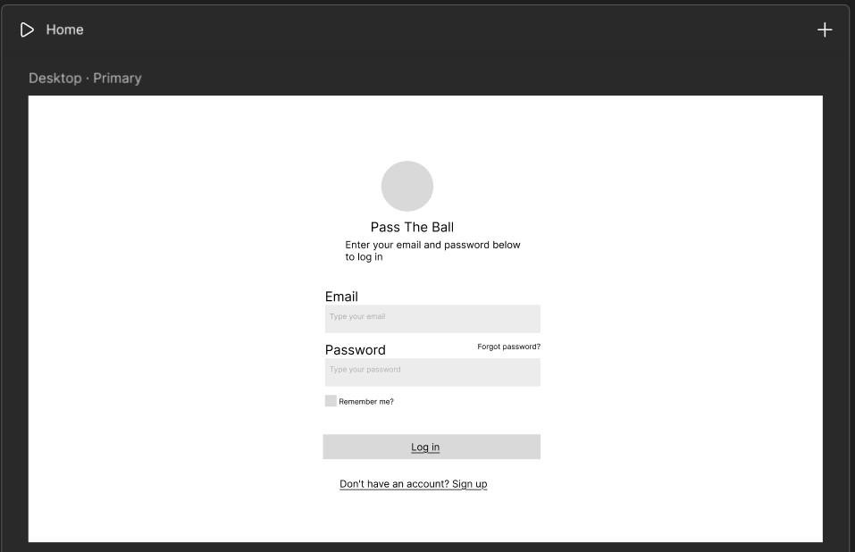
Figure

1

:

Login page

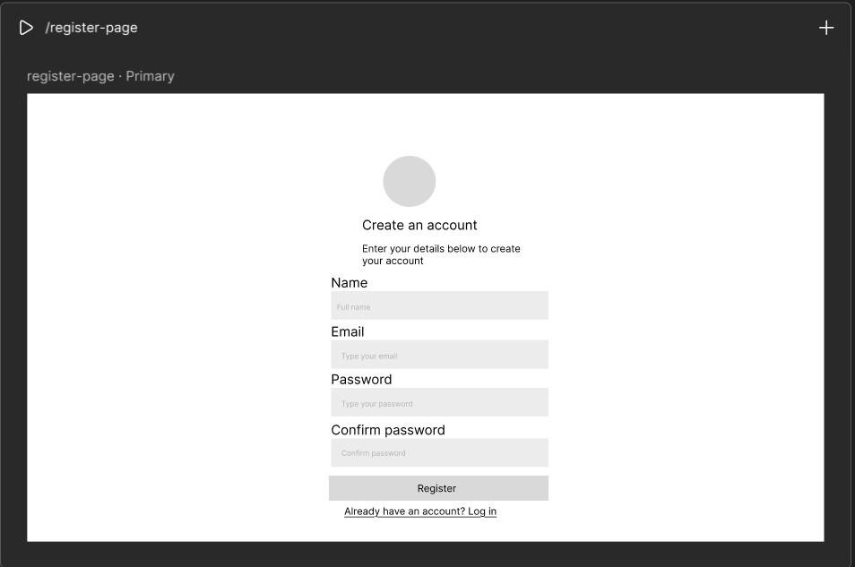
Figure 2: Register page

Index page
This page contains the main content (posts, groups, friends). It is the first page the users are going to see when logged in.
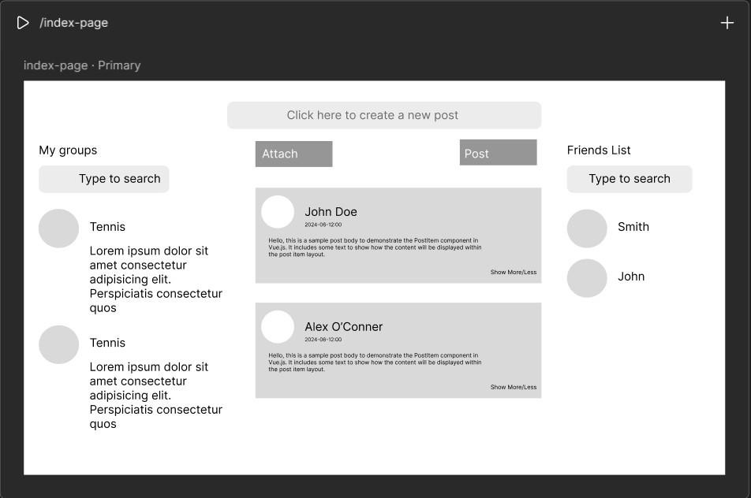
Figure 3: Index page
Breakdown: The page consists of several containers: main one (responsible for displaying the posts/tweets content) and two sidebars showing user’s groups and friends. The authorized user could post new tweets, upload images, videos, documents (post/attach buttons).

Settings (Profile edit)
This page contains the settings menu (emails, passwords, 2fa…).
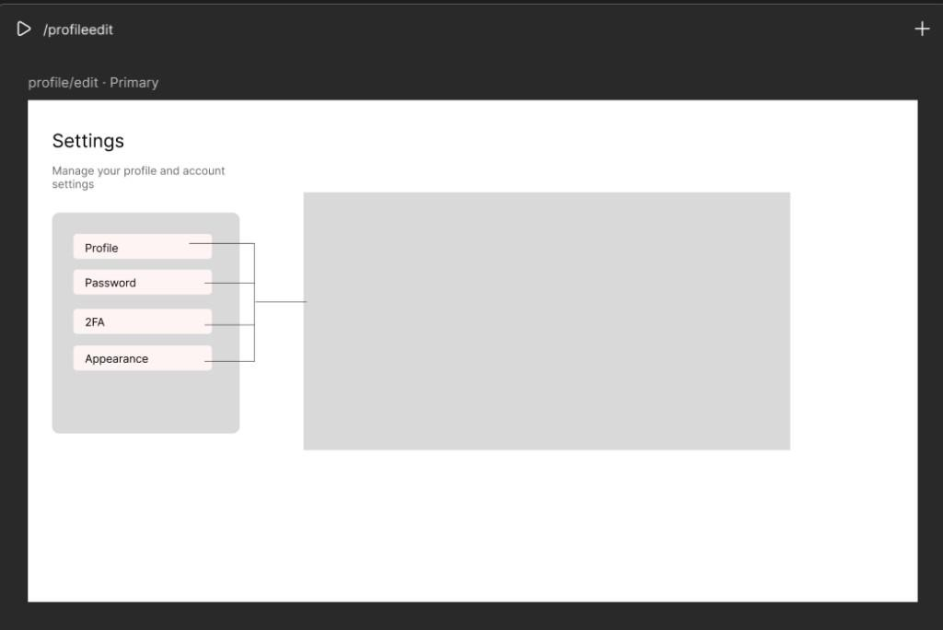
Figure 4: Setting page
Breakdown: The page consists of reusable components for the different sections of the setting menu which will appear on the main container each according to its section.

Profile component
Contains personal information.
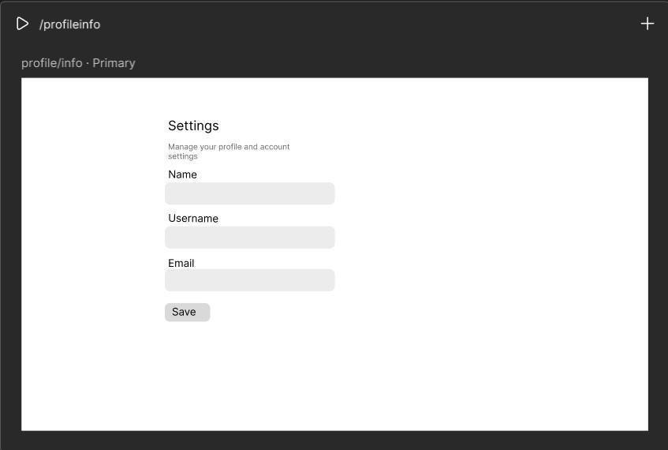
Figure 5: Personal info component

Breakdown: Users can change their personal information by updating the related fields. Password edit component
Contains the password of the user.
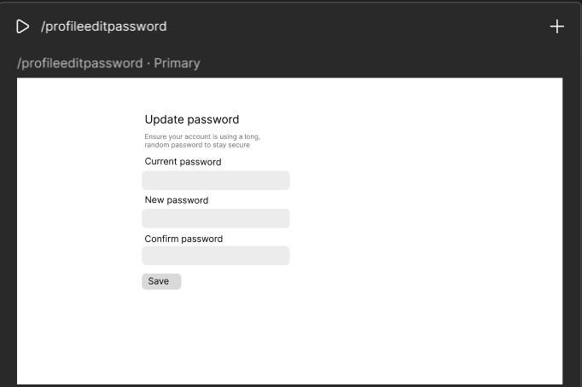
Figure 6: Password component
Breakdown: Users can change their password after providing their previous one and confirm their new password by updating the related fields.

2FA Component
Lets users set up two-factor authentication.
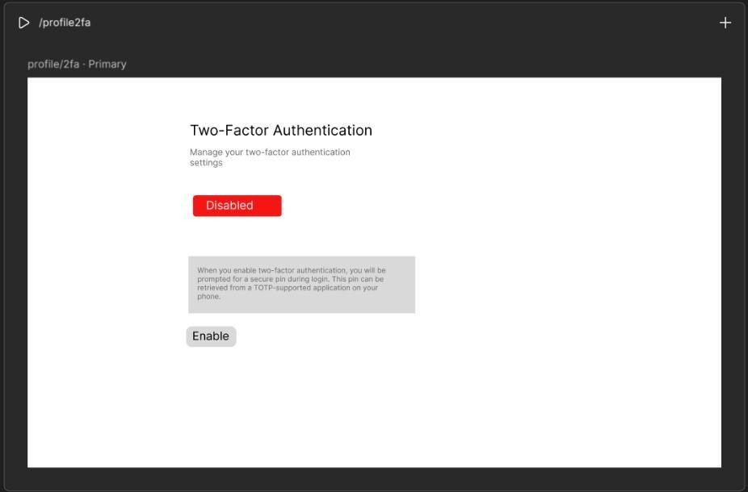
Figure

7

:

2

FA component

Breakdown: Users are prompted to enable/disable their extra layer of protection. The twofactor authentication state (whether enabled or disabled) is displayed to the user.

Appearance component
Lets users set up their preferred appearance of the platform.
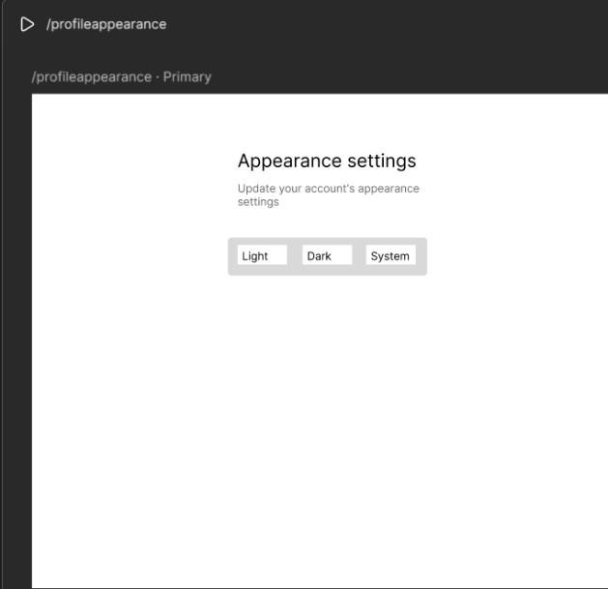
Figure 8: Appearance settings
Breakdown: In a dialog with options for Light, Dark, System mode, the user has the choice to align the platform’s theme to his preferred one.

Techstack decision

Frontend Architecture
- Leveraging Vue.js reusable components alongside Laravel packages helps in boosting the frontend, ensuring clean architecture.
- Laravel’s reactive data binding system allows for real-time updates, useful for user feeds, notification counters, and social interactions without requiring full page reloads.
- Vue.js has proven particularly effective for social media applications, supporting features such as dynamic feeds, user profiles, and real-time chat functionality.
- Inertia.js serves as a bridge between Laravel's server-side capabilities and Vue.js frontend framework, eliminating the need for a separate API while maintaining SPA-like functionality. The approach benefits from simplified data flow, enhanced performance.

Backend Architecture
- PHP offers several advantages for social network development, including excellent scalability, fast loading times, and strong database connectivity. The language's ability to handle high-traffic websites makes it particularly suitable for social platforms that may experience rapid user growth.
- Laravel's design patterns, including Factory, Observer, and Strategy patterns, provide a solid architectural foundation for complex social network features.
- The combination of JavaScript and TypeScript in the techstack provides flexibility for both client side interactivity and server-side operations.

Database Architecture
• MariaDB was chosen due to its superior performance compared to MySQL, particularly in scenarios requiring high concurrency and complex queries.
Feature | MySQL | MariaDB
Real-time analytics | Limited | Limited
Scalability | Moderate (manual tuning needed) | Moderate
Data type support | Primarily structured | Structured + semistructured
Vector search | No | No
Performance | Good for small datasets | Good for small to medium datasets
Table 2: Comparison between MariaDB & MySQL

Elasticsearch for Advanced Search
- Real-time Search: Instantaneous search results across user profiles, posts, and content.
- Social Search Features: Advanced filtering and ranking based on user connections and social graphs.
- Scalable Architecture: Distributed processing for handling large-scale social media data.
- Complex Query Support: Boolean queries, aggregations, and relevance scoring for sophisticated social search features.

Database design
Workbench (RDBMS) was used for generating the EER diagram. It was chosen because of its compatibility with MySQL (MariaDB) with the project’s framework and its easy navigation and intuitive GUI.

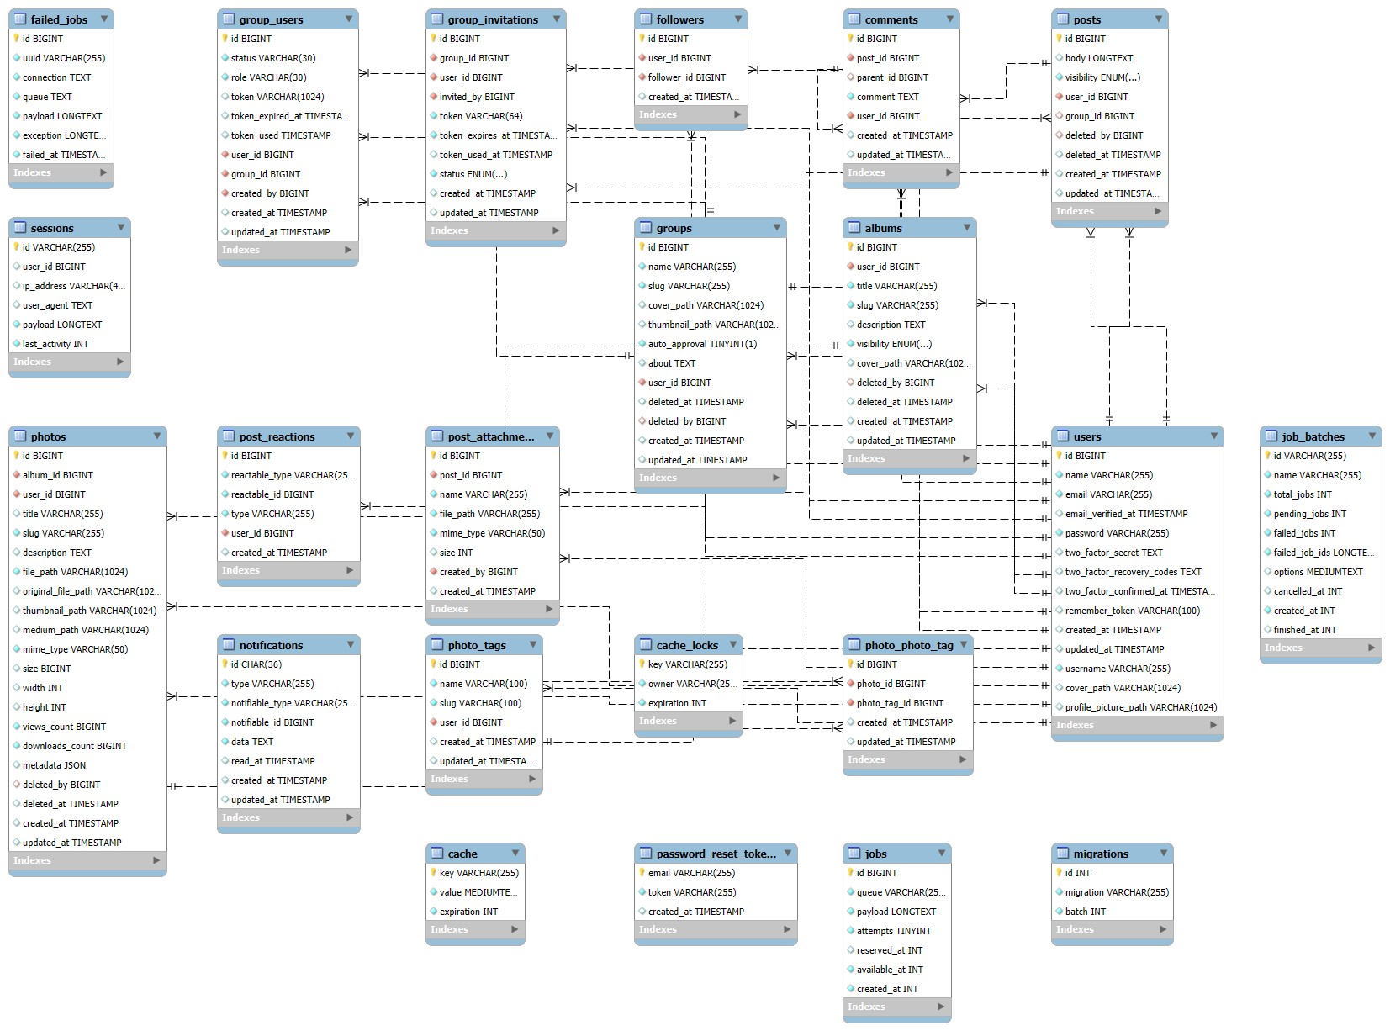
Figure 9: Database diagram

Overview
Core Entities:
- users: This central table stores user information, including their name, email, password, and profile details. It serves as the primary entity that interacts with most other tables.
- posts: This table contains user-generated posts, including the post content (body), the author (user_id), and potentially the group it belongs to (group_id).
- groups: This table defines user groups with details like name, description (about), and cover images.
- comments: This table stores comments made on posts, linking a comment to a specific post (post_id) and the user who wrote it (user_id).
User Interaction and Relationships:
- followers: Manages the follower relationships between users, with user_id representing the user being followed and follower_id representing the user who is following.
- group_users: This is a pivot table that connects users to groups, defining a user's membership and their role within a group.
- post_reactions: This table stores user reactions (e.g., likes) to posts, linking a user to a post they reacted to.
- post_attachments: This table stores files or media attached to posts.
System and Utility Tables:
- jobs, failed_jobs, and job_batches: These tables represent background job processing system used for managing asynchronous operations.
- notifications: This table stores notifications.
- sessions: This table manages user login sessions.
- password_reset_tokens: This table securely stores tokens for password reset requests.
- cache and cache_locks: These tables are used for caching data to improve application performance.
- migrations: This table tracks database schema changes over time (history changes).
Key Relationships:
- A user can create multiple posts, comments, and groups (many-to-one).
- A user can belong to multiple groups, and a group can have multiple users (many-to-many).
- A post can have multiple comments and reactions (one-to-many).
- Users can follow other users (many-to-one/one-to-many).

Tables description ‘users’:
Column | Type | Constraint | Description
Id | BIGINT | PRIMARY KEY | Unique identifier for each user.
name | VARCHAR | NOT NULL | Stored user’s name.
email | VARCHAR | UNIQUE, NOT NULL | Stores user’s email.
password | VARCHAR | UNIQUE, NOT NULL | Stores user’s password.
two_factor_secret | TEXT | UNIQUE | Stores 2fa secret key.
two_factor_recovery_codes | TEXT | UNIQUE | Stores user’s recovery codes for 2fa authentication.
two_factor_confirmed_at | TIMESTAMP |  | Stores user’s 2fa date of creation/activation.
remember_token | VARCHAR | NOT NULL | Used for storing session data about user’s login credentials.
created_at | TIMESTAMP | NOT NULL | Stores data about when the user signed up.
updated_at | TIMESTAMP | NOT NULL | Stores data about when the user made updates on his/her profile last.
username | VARCAHAR | UNIQUE, NOT NULL | Auto generated firstly, then user have chance to change it; used as slug.
cover_path | VARCHAR | NULLABLE | Stores the URL for user’s profile cover image.
profile_picture_path | VARCHAR | NULLABLE | Stores the URL for user’s profile image.
Table 1: Users table ‘followers”:
Column | Type | Constraint | Description
Id | BIGINT | PRIMARY KEY | Unique identifier for each user.
user_id | BIGINT | FOREIGN KEY | Foreign key for user’s following.
follower_id | BIGINT | FOREIGN KEY | Foreign key for user’s followers.
created_at | TIMESTAMP | NOT NULL | Stores data about when the user became a follower/have following.
Table 2: Followers table ‘posts’:
Column | Type | Constraint | Description
Id | BIGINT | PRIMARY KEY | Unique identifier for each post.
body | LONGTEXT | NULLABLE | Stores the post content description.
user_id | BIGINT | FOREIGN KEY | Foreign key for user table (post->user).
group_id | BIGINT | FOREIGN KEY | Foreign key pointing to particular user.
deleted_by | BIGINT | FOREIHN KEY | Foreign key defining the user who deleted the post.
created_at | TIMESTAMP | NOT NULL | Stores data about when a post is created.
updated_at | TIMESTAMP | NOT NULL | Stores data about when a post is updated.
Table 3: Posts table
‘comments’:
Column | Type | Constraint | Description
Id | BIGINT | PRIMARY KEY | Unique identifier for each comment.
post_id | BIGINT | FOREIGN KEY | Foreign key for each comment made on a post(comment->post).
user_id | BIGINT | FOREIGN KEY | Foreign key for the user who made the comment.
created_at | TIMESTAMP | NOT NULL | Stores data about when a comment was made.
updated_at | TIMESTAMP | NOT NULL | Stores data about when a comment is updated.
Table 4: Commenst table
‘groups’:
Column | Type | Constraint | Description
Id | BIGINT | PRIMARY KEY | Unique identifier for each group created.
name | VARCHAR | NOT NULL | Stores the name of a group.
slug | VARCHAR | NOT NULL | Used as slug for the URL.
thumbnail_path | VARCHAR | NULLABLE | Stores the URL path of the group’s thumbnail.
auto_approval | TINYINT | DEFAULT=TRUE | Used as a flag for auto approval.
deleted_at | TIMESTAMP | NULLABLE | Stores the time when deletion is performed.
about | TEXT | NULLABLE | Stores the information about a group.
cover_path | VARCAHAR | NULLABLE | Stores the URL for group’s cover.
user_id | BIGINT | FOREIGN KEY | Foreign key for a user joined in a group.
created_at | TIMESTAMP | NOT NULL | Stores data about when a group is created.
updated_at | TIMESTAMP | NOT NULL | Stores data about when a group is updated.
Table 5: Groups table ‘notifications’:
Column | Type | Constraint | Description
Id | BIGINT | PRIMARY KEY | Unique identifier  for each notification.
created_at | TIMESTAMP | NOT NULL | Stores data about when a notification is created.
updated_at | TIMESTAMP | NOT NULL | Stores data about when a notification is updated.
Table 6: Notifications table.
‘migrations’:
Column | Type | Constraint | Description
Id | BIGINT | PRIMARY KEY | Unique identifier for each created migration.
migration | VARCHAR | NOT NULL, UNIQUE | Migration’s file name identifier.
batch | INT | NOT NULL, UNIQUE | The batch number for the migration, grouping related migrations.
Table 7: Migrations table ‘cache’:
Column | Type | Description | Constraints
key | VARCHAR(255) | The unique key for the cached item. | Primary  Key
value | MEDIUMTEXT | The serialized value of the cached item. | Not Null
expiration | INT | Unix timestamp indicating when the cached item will expire. | Not Null
Table 8: Cache table ‘failed_jobs’:
Column | Type | Description | Constraints
id | BIGINT | Primary key, unique identifier for the failed job entry. | Primary Key
uuid | VARCHAR(255) | A universally unique identifier for the job. | Not Null,  Unique
connection | TEXT | The name of the queue connection used for the job. | Not Null
queue | TEXT | The name of the queue the job was dispatched to. | Not Null
payload | LONGTEXT | The serialized payload of the job, containing all necessary data for execution. | Not Null
exception | LONGTEXT | The full exception trace that occurred when the job failed. | Not Null
failed_at | TIMESTAMP | Timestamp indicating when the job failed. | Not Null
Table 9: Failed jobs table

‘cache_locks’:
Column | Type | Description | Constraints
key | VARCHAR(255) | The unique key identifying the cache lock. | Primary  Key
owner | VARCHAR(25.) | Identifier of the process or entity that currently holds the lock. | Not Null
expiration | INT | Unix timestamp indicating when the lock will expire. | Not Null
Table 10: Cache locks table ‘sessions’:
Column | Type | Description | Constraints
id | VARCHAR(255) | Primary key, unique identifier for the session. | Primary Key
user_id | BIGINT | Foreign key, references the ID of the logged-in user (can be null for guests). | Foreign Key  (users.id), Nullable
ip_address | VARCHAR(4...) | The IP address from which the session originated. | Nullable
user_agent | TEXT | The user agent string of the client browser. | Nullable
payload | LONGTEXT | Serialized session data. | Not Null
last_activity | INT | Unix timestamp of the last activity within the session. | Not Null
Table 11: Sessions table ‘group_users’:
Column | Type | Description | Constraints
id | BIGINT | Primary key, unique identifier for the groupuser relationship. | Primary Key
status | VARCHAR(30) | The user's status within the group (e.g., 'pending', 'active', 'banned'). | Not Null
role | VARCHAR(30) | The user's role within the group (e.g., 'member', 'admin', 'moderator'). | Not Null
token | VARCHAR(1024) | A token associated with the user's group membership (e.g., for invitations). | Nullable
token_expired_at | TIMESTAMP | Timestamp indicating when the token expires. | Nullable
token_used | TIMESTAMP | Timestamp indicating when the token was used. | Nullable
user_id | BIGINT | Foreign key, references the ID of the user. | Foreign Key  (users.id)
group_id | BIGINT | Foreign key, references the ID of the group. | Foreign Key  (groups.id)
created_by | BIGINT | Foreign key, references the ID of the user who added this user to the group. | Foreign Key  (users.id)
created_at | TIMESTAMP | Timestamp indicating when the user was added to the group. | Not Null
Table 12: Group users (pivot) table ‘job_batches’:
Column | Type | Description | Constraints
id | VARCHAR(255) | Primary key, unique identifier for the job batch. | Primary  Key
name | VARCHAR(255) | A descriptive name for the job batch. | Not Null
total_jobs | INT | The total number of jobs in the batch. | Not Null
pending_jobs | INT | The number of jobs in the batch that are still pending. | Not Null
failed_jobs | INT | The number of jobs in the batch that have failed. | Not Null
failed_job_ids | LONGTEXT | A serialized list of IDs of the failed jobs within the batch. | Not Null
options | MEDIUMTEXT | Configuration options for the job batch. | Nullable
cancelled_at | INT | Unix timestamp indicating when the job batch was cancelled. | Nullable
created_at | INT | Unix timestamp indicating when the job batch was created. | Not Null
finished_at | INT | Unix timestamp indicating when the job batch was completed. | Nullable
Table 13: Jobs baches table ‘jobs’:
Column | Type | Description | Constraints
id | BIGINT | Primary key, unique identifier for the job. | Primary  Key
queue | VARCHAR(25.) | The name of the queue the job belongs to. | Not Null
payload | LONGTEXT | The serialized payload of the job, containing all necessary data for execution. | Not Null
attempts | TINYINT | The number of times the job has been attempted. | Not Null
reserved_at | INT | Unix timestamp indicating when the job was reserved for processing. | Nullable
available_at | INT | Unix timestamp indicating when the job becomes available for processing. | Not Null
created_at | INT | Unix timestamp indicating when the job was created. | Not Null
Table 14: Jobs table ‘post_attachments’:
Column | Type | Description | Constraints
id | BIGINT | Primary key, unique identifier for the attachment. | Primary Key
post_id | BIGINT | Foreign key, references the ID of the post the attachment belongs to. | Foreign Key  (posts.id)
name | VARCHAR(255) | The original name of the attached file. | Not Null
file_path | VARCHAR(255) | The path where the attached file is stored. | Not Null
mime_type | VARCHAR(20) | The MIME type of the attached file (e.g., 'image/jpeg', 'video/mp4'). | Not Null
created_by | BIGINT | Foreign key, references the ID of the user who uploaded the attachment. | Foreign Key  (users.id)
created_at | TIMESTAMP | Timestamp indicating when the attachment was created. | Not Null
Table 15: Post attachments table ‘post_reactions’:
Column | Type | Description | Constraints
id | BIGINT | Primary key, unique identifier for the reaction. | Primary Key
post_id | BIGINT | Foreign key, references the ID of the post being reacted to. | Foreign Key  (posts.id)
type | VARCHAR(255) | The type of reaction (e.g., 'like', 'love'). | Not Null
user_id | BIGINT | Foreign key, references the ID of the user who made the reaction. | Foreign Key  (users.id)
created_at | TIMESTAMP | Timestamp indicating when the reaction was made. | Not Null
Table 16: Post reactions table
‘password_reset_tokens’:
Column | Type | Description | Constraints
email | VARCHAR(255) | The email address associated with the password reset request. | Not Null,  Unique
token | VARCHAR(255) | The unique token generated for the password reset. | Not Null,  Unique
created_at | TIMESTAMP | Timestamp indicating when the password reset token was created. | Not Null
Table 17: Password reset tokens table

References
- Nikitins, Nikiti. (Published on 09/04/2024). Code First Approach vs. Database First Approach: Which Is Best? https://builtin.com/articles/code-first-vs-database-first-approach.
- Tim, Kadlec. (2012). Implementing Responsive Design: Building Sites for an Anywhere, Everywhere Web (Voices That Matter) 1st ed. New Riders Pub.
- BM Coder. (2025, August 22). Building a social networking platform with
- Laravel. https://www.bmcoder.com/blog/building-a-social-networking-platform-with-laravel
- WitQuick. (n.d.). Pros and cons of the VueJS. https://witquick.hashnode.dev/pros-and-consofthe-vuejs
- Pattem Digital. (n.d.). Vue JS Application: Benefits & Industry Use
- Cases. https://pattemdigital.com/insight/vue-js-applications-and-case-study/
- SingleStore. (2024, September 18). MariaDB vs. MySQL.
- https://www.singlestore.com/blog/mariadb-vs-mysql/
- Apiumhub. (n.d.). Elastic Search; advantages, case studies & books. https://apiumhub.com/tech-blog-barcelona/elastic-search-advantages-books/
- AI transperancy: PerplexityAI for extensive in-depth research, summarizing articles, papers.
- AI Transperancy: Copilot/Manus AI for information summary.

